**Comparative analysis of traditional machine Learning algorithms:**

After cleaning and pre-processing the dataset we ran some of the traditional machine learning algorithms on the same the reports of which are as follows:

* KNN classifier:

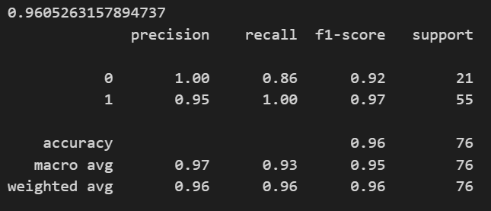

* Support vector classifier:

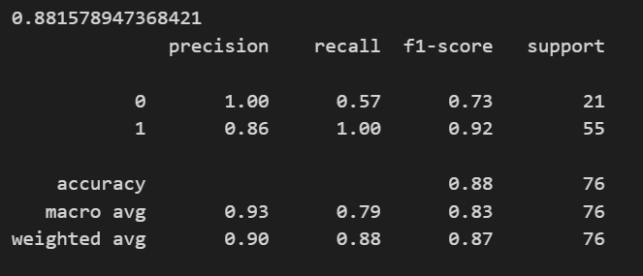

* Decision tree classifier:

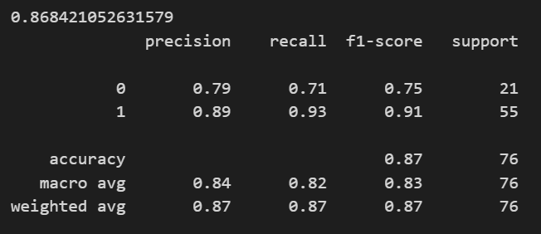

* Random forest classifier:

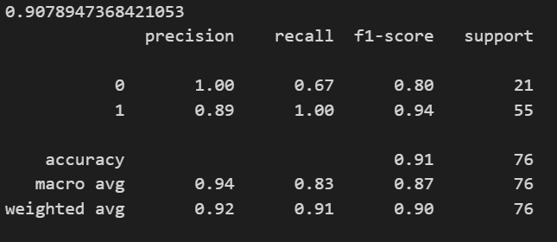

* Naïve Bayes classifier:

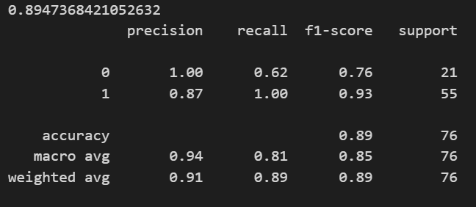

* Logistic regression:

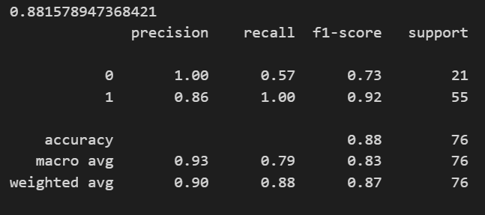

* XGBoost classifier:

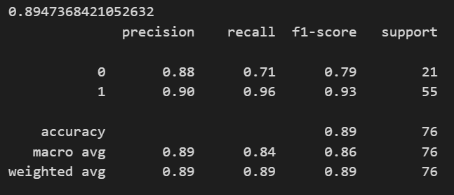

* Gradient boosting classifier:

